SPARK: Simple Play Adaptations to Reference for Kids

Wireless Door Handle Alarm
Description: | Image:
Extremely loud 110dB alarm helps alert others when vibration is detected. There are 3 adjustable settings (off/alarm/chime); chime mode alerts coming and going through the door; alarm mode features a 30-second activation delay to prevent immediate false triggering, but sounds immediately when doorknob is touched any time after the initial 30-second delay. No wiring needed (requires 3xAAA batteries); simply hang the alarm on the inside of the door handle. | 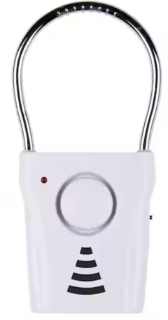  Purchasing Information

Who Might Benefit?
Those who…
• Are responsible for supervising children.
• Act on impulse and try to open doors or gates.
• Attempt to follow a child who opens doors or gates.

Why Use?
Provides an opportunity to…
• Acts as a safety measure for those who try to leave external gates or doors due to:
• Becoming overstimulated in the classroom
• Feeling frightened or upset
• Wandering from supervised areas
• Attention Seeking
Instructions for Use: | Adaptation Ideas:
Environmental Considerations  - Be aware of how the noise level or amount of visual stimulation or busy activities may affect certain children.  - Create boundaries such as a taped box in front of the doorway as a “no stand zone”.  - Place the desk or table where the teacher spends the most class time close to the door to allow for quick intervention.  - Place a stop sign on door or outside gate.  Positioning  - Strategically place the child away from an accessible door. If possible, have an adult positioned close to the child as well as the door to redirect them if they try to leave.  Play/Use with Others  - Create a poster about leaving the area to be reviewed daily in morning circle/meeting, as well as posted on or near the door as a reminder to children who struggle with elopement.  - Combine poster or social stories about leaving designated areas with community signs/traffic lights with concepts of stop (red light), go (green light), wait or caution (yellow light).  - Play Red Light Green Light game and discuss instances of when it is important to stop, and OK to go. | Communication Support  - Visuals displaying options of things children can say or do when they feel like they need to "get away".  - Create lanyards for all staff with visuals including stop, wait, I need a break.  - Create an individual or class Social Story (e.g. Staying With My Class, Running Away, I Can Choose to Be Safe).  DIY Alternatives  - “Sleigh bells” or other movement triggered noise maker on doors and gates.  - Stop signs posted on doors and gates.  - If home has a security system, check to see whether a door alarm can be activated when door opens and/or closes.

Resources:
- See Social Narratives from OCALI’s Autism Center Grab and Go Resource Gallery of Interventions.
- For further information, visit the Social Narratives Autism Internet Module.
- Like Social Stories, Power Cards teach and reinforce academic, behavioral, organizational, and social skills. Power Cards are visual supports that include an individual’s special interest. See Power Cards from OCALI’s Autism Center Grab and Go Resource Gallery of Interventions.
- Reminder Cue Cards from OCALI’s Autism Center Grab and Go Resource Gallery of Interventions help teach and remind individuals how to engage in positive behaviors. Reminder Cue Cards provide “what to do” suggestions when an individual is feeling anxious, stressed, or confused. They also support interactions with peers, and offer ways to self-regulate, and manage emotions.

Ohio Early Learning Standards:

SS. People, Communities, and their Environment: Develops understanding that everyone has rights and responsibilities within a group (1.c.).
- PD&W. Wellness: Demonstrates increasing understanding of safety practices and behaviors (2.f.).

Words to Encourage Play/Use
Stop  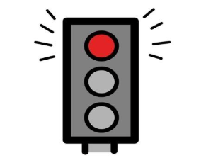 | Go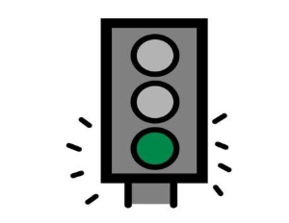 | Wait  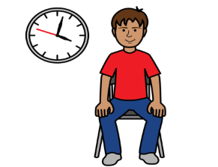
Open 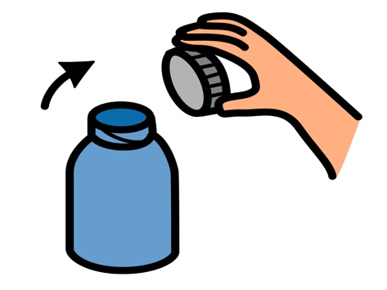 | Close 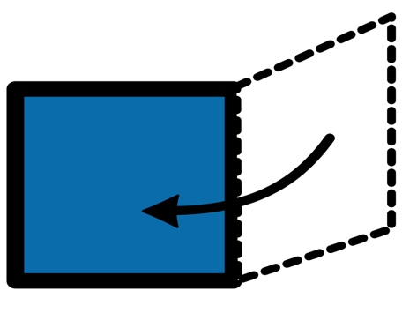 | Help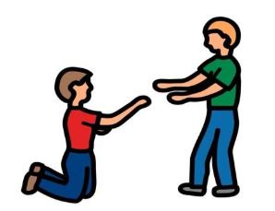
Sad 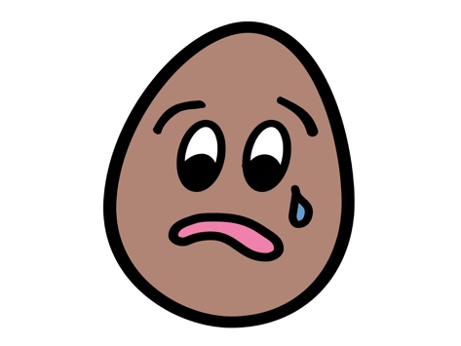 | Mad | Scared  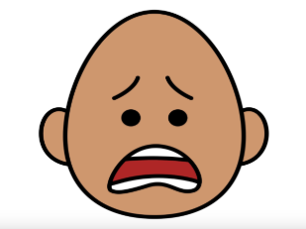
*”Adaptations” adapted from: Haugen’s Modes for Adapting Toys based on materials from the "Let's Play" Project at the University of Buffalo
PCS is a trademark of Tobii Dynavox, LLC. All rights reserved. Used with permission.

